
Image overview

Alfa Laval PureBallast 3 certified for installation on Chinese-flagged vessels

March 2020

Press release

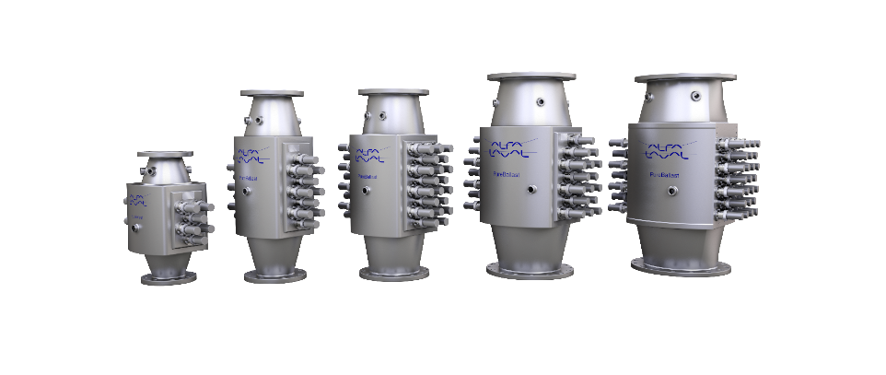

Image name
Alfa_Laval_PureBallast_reactors_shadow.jpg

Caption
Alfa Laval PureBallast reactors

page 2/2

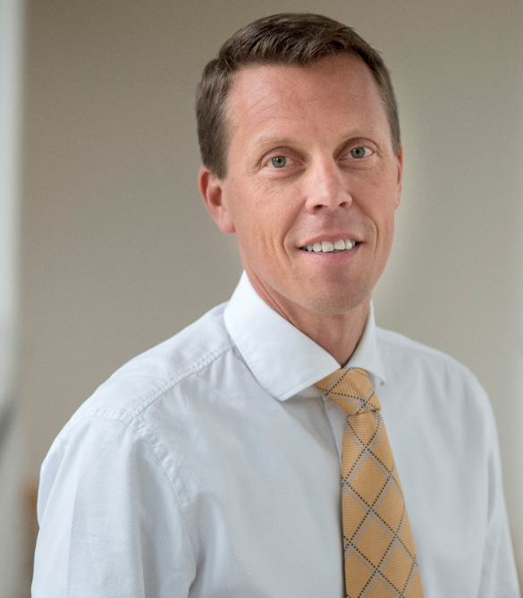

Image name
Peter Sahlén.jpg

Caption
Peter Sahlén, Head of Alfa Laval PureBallast

Peter Sahlén
Head of Alfa Laval PureBallast
Alfa Laval Marine Division
Phone: +46 70 353 54 23
E-mail: peter.sahlen@alfalaval.com

Helena Sannicolo
Vice President Communication
Alfa Laval Marine Division
Phone: +46 8 53 06 52 98
E-mail: helena.Sannicolo@alfalaval.com
www.alfalaval.com/marine

